**OC 523: Final**

**Question 1**

**Part A**

**What is meant by Decoupling:**

    The concept of “decoupling” can have different meanings depending on which area of science you are dealing with. In this case we are defining “decoupling” in reference to biogeochemical cycles. Some of these important cycles include the water cycle, nitrogen cycle and phosphorus cycle but we will focus on the carbon cycle. The two main components of the carbon cycle are respiration and photosynthesis.

    In a broad sense “decoupling” is a concept to look at biological processes that are normally linked together as separate processes. Decoupling allows us to understand how humans can intake matter at a greater rate than their metabolic respiration and enable growth.

**Part B**

**Important Concepts:**

    An understanding of what photosynthesis and respiration are is important to being able to understand the “decoupling” that occurs and its significance to marine ecology.

* Photosynthesis is the use of light energy to create ATP and also to fix carbon dioxide
* Respiration is a process that involves the production of energy through intaking oxygen and releasing carbon dioxide through the oxidation of complex organic substances
* Autotrophs generally utilize energy from the sun in order to make sugars and macromolecules
* Heterotrophs do not synthesize their own food but rely on plants and animals for nutrition
* Gross Productivity is the total photosynthesis occuring
* Net productivity is gross photosynthesis minus plant respiration

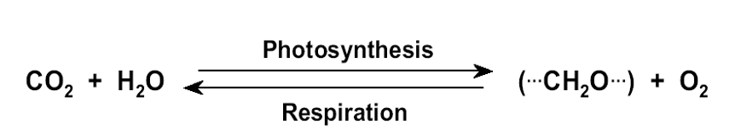

    Photosynthesis and respiration are inherently coupled as can be seen from the symbiotic relationship between humans who respire and plants and trees who utilize this carbon dioxide. In the marine environment respiration is measured by the rate of decrease in seawater oxygen content.

**An Example of Decoupling:**

    In the pelagic environment the decoupling of respiration and photosynthesis allows for phytoplankton to be a primary producer creating biomass that can be grazed upon as the base of the food web. Phytoplankton are a photoautotrophic primary producer and are responsible for nearly fifty percent of all global carbon fixation (Vaulot, 2008). This “decoupling” enables Spring Blooms that often occur in temperate coastal areas and the subarctic North Atlantic. Phytoplankton are responsible for these blooms. However, without “decoupling” phytoplankton carbon fixation could be considered to have a net gain of zero or less.

**The Resulting Phenomenon:**

    The resulting phenomenon of this decoupling is the Spring Blooms that occur when there is an increase in available PAR irradiance. During this time photosynthesis rates are greater than respiration; thus allowing for these blooms to occur. Spring Blooms are a fascinating phenomenon and allow for the sustaining of life in often very harsh conditions.

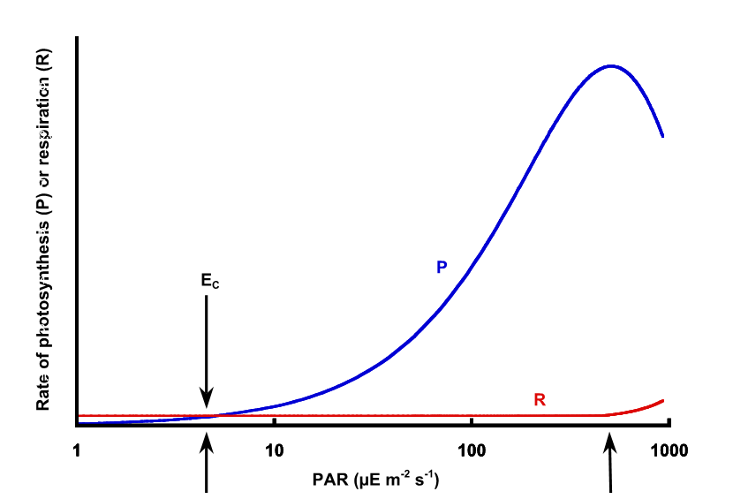

**Figure 1.1:** Respiration and Photosynthesis

**Processes Responsible for Decoupling:**

    The events that occur and allow for these blooms include the following. Phytoplankton stock is low in the winter when net losses from the photic zone are larger than potential net growth in spite of their being sufficient nutrients. Lower sun angles, short days and vertical mixing also contribute to keeping growth rates slow (Behrenfeld, 2010). During the spring there is greater irradiance and a reduction in winds which lowers the loss rates. Figure 1 really demonstrates this phenomenon and also shows solar radiation as a key process that helps with this decoupling.

    Another interesting phenomenon is that as phytoplankton growth rates rise you would expect to see a result of an increase in respiration. However, as a “decoupled” process respiration may not increase as much with the growth rate. Some processes that may be responsible for the “decoupling” include environmentally induced changes in metabolic rate, changes in overall bulk cell composition or the uncoupling of catabolism from anabolism.

**Question 2**

**Introduction:**   
 Diel migration patterns as exhibited by zooplankton is an amazing phenomenon that is said to have been first observed during World War II. The story is that the Allied Troops saw the effect of this mass transfer of biomass as it interfered with sonar readings making them concerned that there were enemy submarines in the area (Hill, 2005). Researchers were able to discover that what was occuring was in fact a daily migration of zooplankton for ecological reasons. Another major vertical migration trend is ontogenic migration which is driven by seasonal or life stage patterns.

    To understand what drives migration it is important to understand a few important ecological and biological concepts. In polar regions the environment is dominated by the availability of light, temperature and ice cover. Besides environmental factors organisms are driven to meet three basic needs.

* A way to generate ATP which is an energy currency of the cell
* A source of elements that can be utilized to create macromolecules
* A source of reducing equivalents

**Part A**

    There are a number of different hypotheses that have been proposed to explain ecological benefits gained by these vertical migration patterns.

**Diel Vertical Migration:**

Diel vertical migration is one of the most common forms of zooplankton migration. The main hypothesis proposed to explain the benefit of this energy consuming behavior is the ability to migrate into food-filled shallow waters during periods of lower irradiance; generally the night time. Zooplankton feed on phytoplankton which are generally more abundant in the Euphotic Zone. When the day time begins these zooplankton migrate downward into the mesopelagic zone to avoid predation by other organisms.

**Ontogenic Vertical Migration :**

    Ontogenic vertical migration is where different pelagic organisms spend different parts of their life cycle at different depths. The hypothesis for *Calanus finmarchicus* utilizing this type of migration is that in response to light levels, day length, food availability, lipid stores or temperature they enter diapause. There are a number of benefits for this but the primary benefit is the ability to survive environmental adversity. Diapause for these organisms includes migrating to depth (ontogenetic vertical migration), reducing their metabolism, an end of feeding and survival on a lipid-rich oil sac. In extremely harsh environments this migration may be the sole way some organisms can survive long harsh winters.

**Part B**

The regions of the globe where this may be expected to be found would be harsh environments; possibly those that have limited light during long dark winters like Antarctica and the Arctic. I would expect this to occur in the subarctic, SubAntarctic, Antarctic and high latitude zones. The reason why I would expect this is that these regions often are without light for prolonged periods of time and periods of light, blooms and better climate occur seasonally.

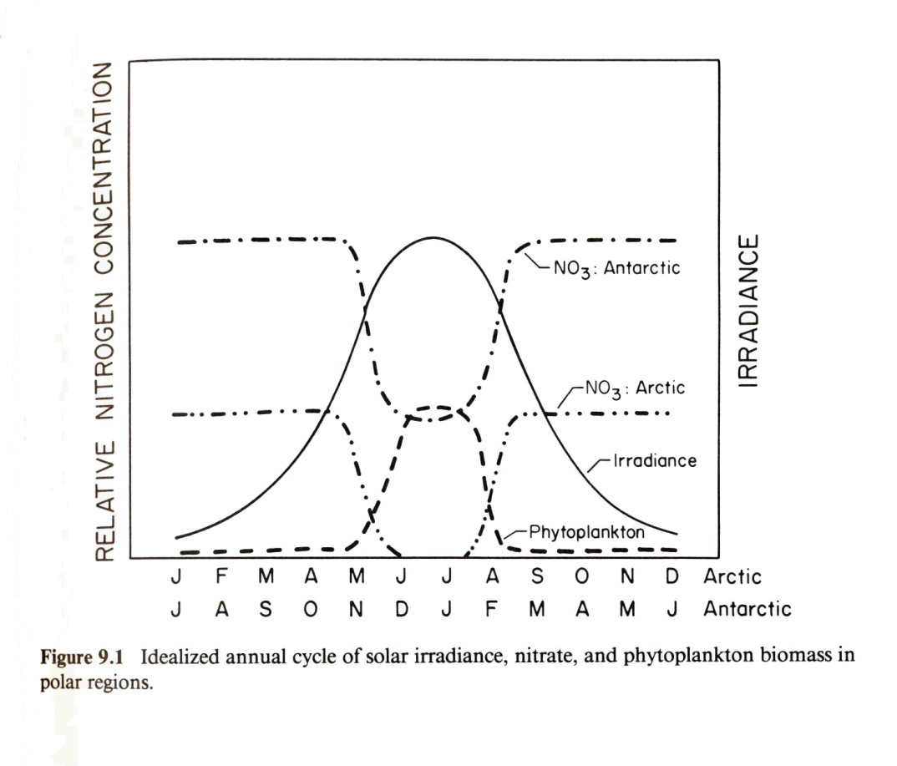

**Figure 2.1:** Availability of Nitrogen and Irradiance

**Part C**

     We don’t fully understand what causes organisms to leave diapause. Some theories put forth for entering diapause include the day length and light levels, the availability of food, lipid stores and temperature. Some cues put forth for leaving diapause are similar but include the length of the day and light levels, lipid stores, temperature or an internal clock.

    Climate change research has shown that rising carbon dioxide and climate change are associated with shifts in nutrient input, oxygen, ocean acidification, and temperature. These changes most likely will have a wide range of biological effects. Changes are also occurring at the population level from changes in species interactions, dispersal patterns and physiological intolerance to these environmental shifts (Doney, 2012).

    I would expect both spatial and temporal changes to ontogenetic migration given our current climate change projections. I would expect that temporal changes could be driven through changes in temperature and species internal clocks. Large shifts in climate may cause them to enter or leave diapause earlier. Spatial changes may also occur as research has shown physiological intolerance for environmental shifts. Changing environments could also change the lipid stores of these specimens which could have long term effects on their vertical migration patterns.

**Question 3**

**Introduction:**

    Organisms have evolved in remarkable ways in order to survive in their environments. Plankton consists of both phytoplankton and zooplankton and both have evolved in a number of ways to be suited to their environment. Plankton comes from a Greek word whose root means “wanderer” which is a fitting description of these organisms that drift or swim weakly in often turbulent ocean waters.

**Part A**

     Plankton are a diverse group that have many specific adaptations that help them to be successful in their environment. One of the most important structural adaptations is the ability to float or drift in the water column. For phytoplankton this means the ability to stay in the Euphotic Zone and for zooplankton the ability to engage in diel vertical migration. Water density helps plankton float but they also have developed mechanisms to help keep them from sinking to the bottom. Their small size allows them to have a large surface to volume ratio which helps them float. Some adaptations include flat bodies and spines which helps increase the surface area of their body and still minimizes volume. Other similar structural adaptations include things like lateral spines and ion replacement and flagella (of some species) which can be also utilized for locomotion (Miller, 2012).

    Another important aspect of plankton is their ability to reproduce rapidly. Plankton are small and can often be entirely consumed when being grazed upon. In a terrestrial environment you may picture grazers as terrestrial animals grazing on leafy foliage; rarely would you see a grazer eat the whole plant. Plankton are so small that often a grazer consumes the whole plankton and it is simply gone. To adapt to this phytoplankton are able to reproduce rapidly; often being able to double in number one or more times per day. In the absence of heavy grazing and in favorable conditions (light, temperature and nutrients) you can experience rapid exponential growth (Bougis, 1976).

**Part B**

Biologist belief is that pelagic autotrophs are small because it enables them to have a large surface area in relation to their total biomass. This allows them to absorb nutrients like iron, phosphate and nitrate from a very dilute solution. This nutrient absorption is different and harder for pelagic autotrophs then it is for terrestrial plants. For this reason, plankton are limited by nutrient supply from a dilute solution. The small size creates a large relative surface through which diffusion can transport limited but important macronutrients and micronutrients phytoplankton need to grow and survive. Some of these important nutrients include nitrogen, phosphorus and iron (Miller, 2012).

**Part C**

    Generally, larger plankton require more nutrients. Exceptions exist where they are able to obtain these higher levels of nutrients. What allows them to break the rules often comes from physical processes in the ocean. Vertical mixing is one of the primary drivers of nutrients into regions where phytoplankton can use them. However, research has shown that increasing stratification which dampens nutrient cycling could lead to a decline in the relative abundance of larger phytoplankton.

**Question 4**

**To:** Governor of Oregon

**From:** David Vasquez

**Subject:** Debbie Mackenzie’s Hypothesis on Ocean Starvation

**Sumary of Findings**

    There is currently a lot of concern locally and globally about ecological and environmental issues. Debbie MacKenzie’s claims that the oceans are starving have been looked into in order to determine what specific policies or actions should be taken. Our finding is that some of her methodologies, theories and findings are questionable but that there is almost broad universal consent that issues exist driven by climate change, overfishing, population growth and human activity.

    There is a recent report from the Department of Energy specifically addressing the starvation of oceans (Moore, 2018). If corrective action is not taken it could lead to far reaching consequences and we recommend actions the Governor's Office can take to drive change in Oregon and hopefully at the Federal Level. We understand the importance of fisheries and agriculture to Oregon’s economy and take into consideration ways to continue practicing sustainable and environmentally friendly use of these resources. Below are the eight specific recommendations which are detailed further at the end of our report.

* **Policy Recommendation 1:** Establish an Economic andEcological Task Force
* **Policy Recommendation 2:** Pursue Federal and State Funding
* **Policy Recommendation 3:** Encourage more Innovation and Entrepreneurship
* **Policy Recommendation 4:** Encourage more Citizen Science
* **Policy Recommendation 5:** Focus on Upholding the Magnuson-Stevens Fishery Conservation and Management Act
* **Policy Recommendation 6:** Utilize Technology for all Initiatives
* **Policy Recommendation 7:** Work to Support Local Communities that rely on Agriculture
* **Policy Recommendation 8:** Pursue Clean Energy Alternatives

**Ecology and Oceanography Overview**

Ocean life exists in a food web similar to what we experience in terrestrial environments. Just as plants are drivers of life for humans, phytoplankton are the primary producer of this ocean food web. Phytoplankton are small plant-like organisms in the sea that live near the surface (the Euphotic Zone) in order to utilize sunlight for photosynthesis. Zooplankton are small animal-like creatures that graze upon them; both form essential parts of the ocean food web.

     Phytoplankton are foundational to life on earth responsible for nearly fifty percent of all global carbon fixation; a process needed to sustain life (Vaulot, 2008). These food webs exist in trophic levels and research often looks at top-down or bottom-up forcing in these webs and how this drives change. An example of top-down forcing would be wolves hunting deer which are grazers of plants. Changes to plants that affect wolves would be a bottom-up forcing effect (Pershing, 2015).

    Similar to how humans need nutrients these phytoplankton also need nutrients to survive. One important element needed is carbon which is part of the biogeochemical carbon cycle (Quigg, 2003). The accepted theory is that physical forcing helps drive these nutrients into the upper ocean levels where they can be utilized by phytoplankton. These nutrients enter the euphotic zone through upwelling, terrestrial and atmospheric sources. New production depends on this ocean mixing. Export production is the organic matter produced in the ocean that sinks downwards to lower ocean levels. This process is part of the biological pump and is very important to controlling atmospheric carbon dioxide (Thompson, 2012).

    Why this is important is ecosystems exist in balance and overfishing has become a massive problem that can have unintended consequences throughout a food web. A surprising example fo this would be wolves being reintroduced in Yellowstone National Park that triggered a positive top-down trophic cascade. Their reintroduction has helped increase beaver populations, aspen trees and vegetation (Farquhar, 2019).

**The Hypothesis Debbie MacKenzie has Proposed**

    Debbie MacKenzie is a self-taught naturalist who claims that the ocean is starving due to the overharvest of nekton. She has developed a theory that fish directly help with ocean mixing through a reverse biological pump. H er claim is that the removal of nekton has lowered nutrients and has had a direct negative effect on the entire ocean’s food web. She is concerned that because she lacks academic credentials her research is not taken seriously.

**Issues with Her Science**

There are a few issues with her research that should be considered. One issue is part of her claims stem from childhood memories, stories from fishermen and a painting of the coastline. These sources of data may be accurate but they need to pass more academic rigour to meet the requirements of peer reviewed research or to be implemented for policy recommendations. While there are issues with the peer review process and it can discourage citizen science it still remains the best way of ensuring the validity of science being undertaken.

    Another issue she points out is that the methods being utilized by the DFO are not accurate. They have been reporting fish stock by a method called bottom trawling and extrapolating these results to upper ocean levels. There may be some issues with the methods utilized by the DFO but fortunately other research exists about fish stock and we do know overfishing is an issue. Finally, she makes claims that the starvation is being induced through bottom-up forcing rather than top-down forcing. Research in this has shown that often both effects can be occurring simultanesouly (Pershing, 2015). One other issue is her research focuses on a small area but often ecosystems should be looked at on a broader temporal and spatial scale. There is a field of research called landscape ecology that does this and often relies on multiple scientists because of how intensive it is to correctly evaluate hypotheses (Platt, 2008).

**Summary of the Issue**

    From looking into this it seems that while her research may lack academic rigour and challenge currently held assumptions we have enough research from scholars across the globe to believe there are serious issues facing our oceans. Human induced activity including overfishing and climate change need to be addressed. Climate change and rising carbon dioxide levels are associated with changes in ocean acidification, oxygen content, nutrient input, temperature, circulation and other biological effects (Toseland, 2013). Overfishing can lead to a decline and collapse in stock, reduction of top predators and loss of biodiversity. It can also have indirect effects including stock rejuvenation where more mature fish become scarce. This might lend credence to her findings of “slinky” cod.

**Policy Recommendations for the Governor and State of Oregon**

    It would seem then that whether or not her particular theories are correct there is near global consensus that we must make changes to avoid the negative consequences from misuse of natural resources, climate change and population growth. These decisions must also be made taking into consideration the importance of the economic impact the fishing industry has to Oregon’s economy. Currently, the total economic contribution includes almost 7,000 jobs and total economic output of almost $700 million dollars (ODF, 2019).

    The goal will be to slowly implement changes that can prevent this “starvation” of the oceans. Another goal is for Oregon to implement changes that are recognized nationally so that Oregon can be seen as a model for national policy changes that could have a meaningful world wide impact. These recommendations are also broad reaching but by putting together a task force they can be slowly implemented as funding and resources allow.

**Policy Recommendation 1:** Establish an Economic andEcological Task Force

    While there are a number of task forces the goal would be to create a unified task force responsible solely for balancing economic and ecological interests. It would be a committee that could be composed of business leaders, scholars, politicians and citizens. This committee would help to drive the further policies listed below. The committee should reevaluate once a year and assess its own effectiveness. If the committee is not making progress it should have a probation year and if still ineffective should be disbanded or reformed.

**Policy Recommendation 2:** Pursue Federal and State Funding

    The NSF and many other agencies have funding related to scientific research, commercialization and innovation. Part of the task force would be a team of individuals who could help secure funding for researchers and small businesses.

**Policy Recommendation 3:** Encourage more Innovation and Entrepreneurship

    Innovation is one of the primary ways to help with the issues facing mankind. Tesla is a prime example of a company working to reduce fossil fuels. Working to form a partnership with local venture capital funds and angel investors could lead to innovation that helps solve the problems we know exist.

**Policy Recommendation 4:** Encourage more Citizen Science

    There are many ways of doing this but the first would be having local elementary schools partner with research institutions. Graduate students could spend a few hours each term teaching and working with students educating them about natural resources and the importance of innovation.

**Policy Recommendation 5:** Focus on Upholding the Magnuson-Stevens Fishery Conservation and Management Act

    There currently is a Magnuson-Stevens Fishery Conservation and Management Act to prevent overfishing but there exists scientific and managerial uncertainty in the process of how this is carried out. The committee would work to help insure not just the letter of the law but the spirit that went behind its drafting.

**Policy Recommendation 6:** Utilize Technology for all Initiatives

    Technology is rapidly changing and can be implemented in all aspects of these recommendations. A first idea is working on a shared research database where scientists can easily store and access past research data. This would help prevent siloed research and possibly open ways to answer new questions.

**Policy Recommendation 7:** Work to Support Local Communities that rely on Agriculture

    It is important to support local agricultural workers. By including them and their economic concerns we can assure their buy in as those struggling to survive are less inclined to feel concern over the environmental impacts of their decisions.

**Policy Recommendation 8:** Pursue Clean Energy Alternatives

    As the governor of Oregon your office has the ability to implement policies and programs related to clean energy in Oregon that if done correctly could become a standard for federal initiatives. Over time these Federal initiatives and policies could help drive change on a global scale.

**Citations**

Behrenfeld MJ. 2010. *Abandoning Sverdrup's Critical Depth Hypothesis on phytoplankton blooms.* Ecology 91:977–89

Bougis, Paul. *Marine Plankton Ecology*. Amsterdam : New York: North-Holland Pub; American Elsevier Pub. 1976.

Doney, Scott C., Mary Ruckelshaus, J. Emmett Duffy, James P. Barry, Francis Chan, Chad A. English, Heather M. Galindo, Jacqueline M. Grebmeier, Anne B. Hollowed, Nancy Knowlton,

Jeffrey Polovina, Nancy N. Rabalais, William J. Sydeman, and Lynne D. Talley. *"Climate Change Impacts on Marine Ecosystems.*" Annual Review of Marine Science 4.1: 11-37.

“Economic Contributions Of Oregon’s Commercial Marine Fisheries .” Oregon Department of Fisheries and Wildlife, Oct. 2019.

J.K. Moore, W. Fu, F. Primeau, G.L. Britten, K. Lindsay, M. Long, S.C. Doney, N. Mahowald, F.M. Hoffman, and J.T. Randerson, *"*[*Sustained climate warming drives declining marine biological productivity*](https://www.osti.gov/pages/biblio/1425334-sustained-climate-warming-drives-declining-marine-biological-productivity)*.*" Science 359, 1139 (2018). [DOI: 10.1126/science.aao6379]

Farquhar, Brodie. “*Wolf Reintroduction Changes Ecosystem*.” My Yellowstone Park, 15 Jan. 2019, [www.yellowstonepark.com/things-to-do/wolf-reintroduction-changes-ecosystem](http://www.yellowstonepark.com/things-to-do/wolf-reintroduction-changes-ecosystem)

Miller, C. B., & Wheeler, P. (2012). Biological Oceanography. Hoboken, NJ: John Wiley and

Sons.

Pershing AJ, Mills KE, Record NR, Stamieszkin K, Wurtzell KV, Byron CJ, Fitzpatrick D, Golet

WJ, Koob E. 2015 *Evaluating trophic cascades as drivers of regime shifts in different ocean ecosystems.* Phil. Trans. R. Soc. B 370: 20130265.

Platt, T., S. Sathyendranath *Ecological indicators for the pelagic zone of the ocean from*

*remote sensing*. Remote Sensing of Environment, 112 (8) (2008), pp. 3426-3436

Thompson, W.J. Sydeman, J.A. Santora, B.A. Black, R.M. Suryan, J. Calambokidis, W.T.

Peterson, S.J. Bograd. *Linking predators to seasonality of upwelling: using food web indicators and path analysis to infer trophic connections Progress in Oceanography*. (2012)

Toseland, S. J. Daines, J. R. Clark, A. Kirkham, J. Strauss, C. Uhlig, T. M. Lenton, K.

Valentin, G. A. Pearson, V. Moulton, and T. Mock. *"The Impact of Temperature on Marine Phytoplankton Resource Allocation and Metabolism."* Nature Climate Change 3.11 (2013): 979-984. Web.

Quigg, A., Finkel, Z., Irwin, A. et al. *The evolutionary inheritance of elemental stoichiometry in*

*marine phytoplankton*. Nature 425, 291–294 (2003)

Vaulot, D., Eikrem, W., Viprey, M. & Moreau, H. *“The diversity of small eukaryotic*

*phytoplankton in marine ecosystems”.* FEMS Microbiol. Rev. 32, 795820 (2008)